Baltic WEEE workshop

Taking on the e-waste challenge in the Baltics

Hotel Palace Tallinn
Vabaduse väljak 3
Tallinn, Estonia

Thursday, 1 October 2015

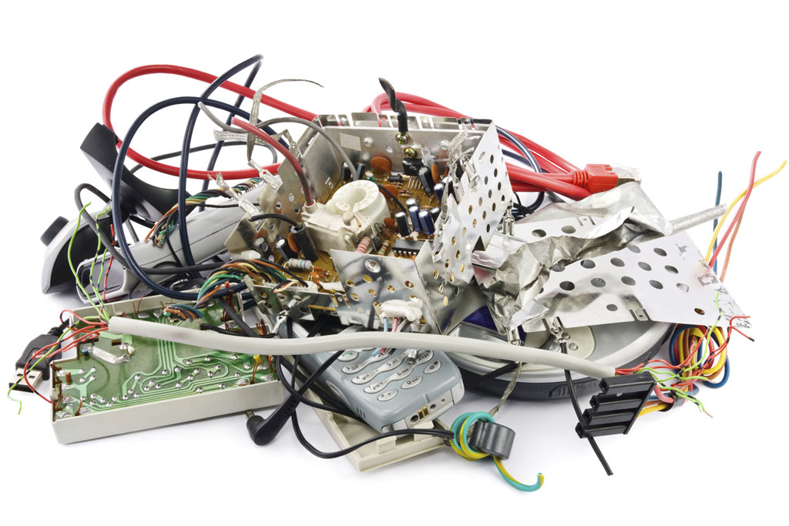
Photo credit: ITU
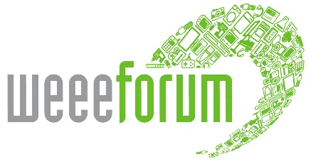
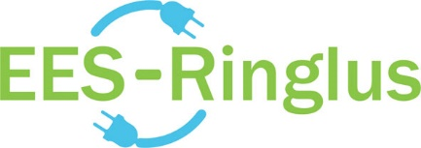

WHY JOIN THIS EVENT?
In 2003, the Environment Ministries in the Baltics set up the Baltic Environmental Forum, a platform to allow for co-operation among actors on the market. Manufacturers, importers, collectors and processors, as well as local governments, state authorities and the European Commission gathered at Laulasmaa, a stone’s throw from Tallinn, the capital of Estonia, keen to learn how to implement Directive 2002/96/EC on WEEE and motivated to share best practices.
The EU law said that by 2005 member states were to ensure that WEEE collection systems would be in place. That was ten years ago. Ten years have also expired since the set-up of the Estonian association of producers of electrical and electronic equipment and of EES-Ringlus, the WEEE collection system.
Transnational meetings of the Baltic states on related subject matters, such as the one that took place in 2003, have, however, not been organized since. We believe that a regional get-together this year is relevant and timely. We need to understand how to put the recast Directive 2012/19/EU into practice and evaluate the accomplishments of the past decade. EES-Ringlus and the WEEE Forum invite you to join us and share your ideas, know-how, questions and views. What have we learned in the past ten years?
The Baltic WEEE workshop is a one day discussion forum examining three related topics that we think are important: WEEE collection, WEEE proper treatment, and WEEE illegal trade.
- Topic I, Collection – Estonia, Latvia, and Lithuania, the three Baltic nations, have each approached the achievement of collection target rates in their own specific manner. Unsurprisingly, collection rates vary. What are the important success factors related to collection? How should waste producers be directed towards the right ways to collect? What is the role of collection points located near local governments as well as store-based collection points?
- Topic II, Proper treatment – What constitutes proper treatment? What could be the effect of recycling standards? What are the recycling rates for different types of WEEE?
- Topic III, Countering illegal trade – Disregarding stringent EU regulations, almost two-thirds of Europe’s estimated 9.45 million tons of used and waste electrical and electronic equipment each year is mismanaged. Countering WEEE Illegal Trade (CWIT), a two-year EU-funded inquiry, has found out that illegal or sub-standard e-waste activities within Europe involve ten times the volume of e-waste shipped outside Europe in undocumented exports. The CWIT project was undertaken by a consortium of experts and stakeholders that include the United Nations University, INTERPOL and the WEEE Forum. What initiatives can we take to counter illegal operations? How can we improve enforcement? Should we introduce a ban on cash transactions?

AGENDA
Thursday, 1 October 2015

08.30 – 09.00 | Registration and coffee
09.00 – 09.15 | Opening remarks | Phil Morton – President, WEEE Forum (UK)
09.15 – 09.30 | Keynote speech | Thomas Lindhqvist – Thomas Lindhqvist, IIIEE Lund University (SE)
09.30 – 11.00 | Topic I  Collection targets  (Including Q&A) | Chair: Margus Vetsa – EES-Ringlus (EE)  Jaco Huisman – United Nations University – “WEEE stocks and flows in Europe” (NL)  Ilze Donina – Ministry of Environment (LV)  Kalev Aavik – Law firm Laus & Partners (EE)  Jan Bielefeldt – Ekogaisma/Ekosviesa (EE,LV,LT)  Tarmo Lindemann – Kuusakoski (EE)
11.00 – 12.30 | Topic II  Proper treatment  (Including Q&A) | Chair: Leo Donovan – WEEE Ireland (IE)  Marta Yuste – CECED (BE)  Dalius Krinickas – Ministry of Environment (LT)  Peeter Eek – Ministry of Environment (EE)  Almontas Kybartas – EMP Recycling (LT)  To be confirmed – Manufacturer (country)
12.30 – 13.30 | Lunch
13.30 – 13.40 | Opening remarks | Pascal Leroy – WEEE Forum
13.40 – 16.20 | Topic III  Illegal trade  (Including Q&A) | Chair: Pascal Leroy – WEEE Forum (BE)  Jaco Huisman – United Nations University – Lucía Herreras-Martínez – WEEE Forum – “Key findings and recommendations from the EU-funded Countering WEEE Illegal Trade project”  Mari-Liis Ummik – Ministry of Environment (EE) – "Measures to combat illegal WEEE traffic at state level"  Klaus Willke – Expert (DE)
16.20 – 16.30 | Closing remarks | Pascal Leroy – WEEE Forum

SPEAKERS
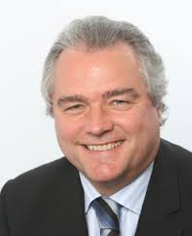
Philip Morton Thomas Lindhqvist
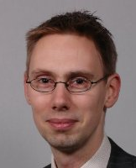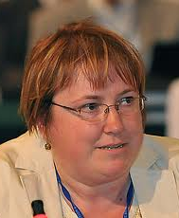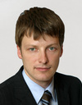
Margus Vetsa Jaco Huisman Ilze Donina Kalev Aavik
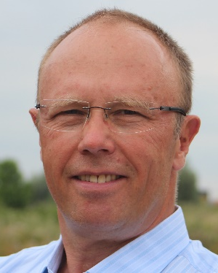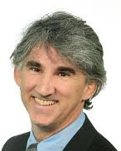
Jan Bielefeldt Tarmo Lindemann Leo Donovan
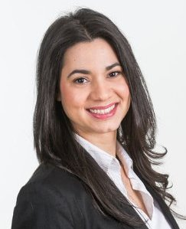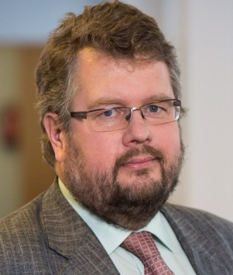
Marta Yuste Almontas Kybartas Peeter Eek Dalius Krinickas
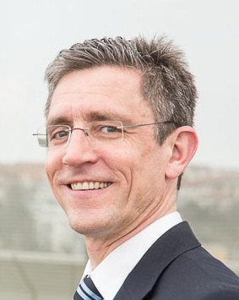 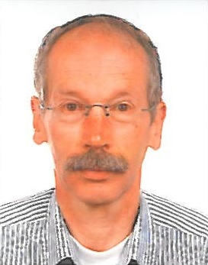 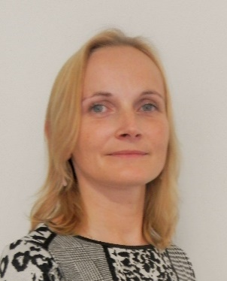 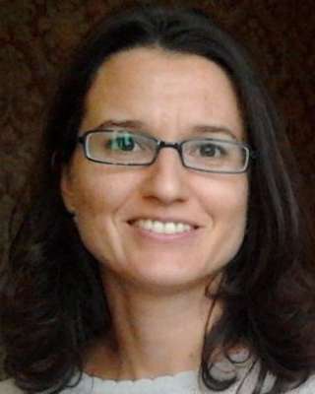 Pascal Leroy Klaus Willke Mari-Liis Ummik Lucía Herreras-Martínez

